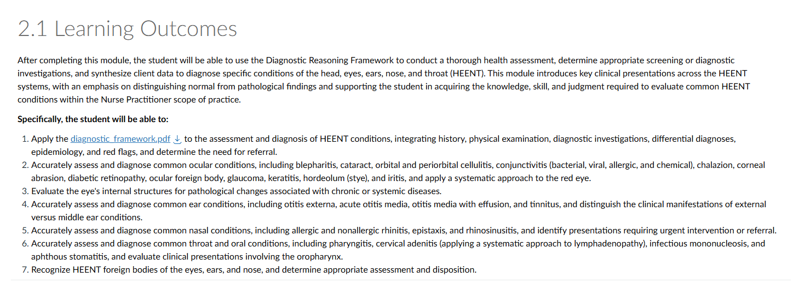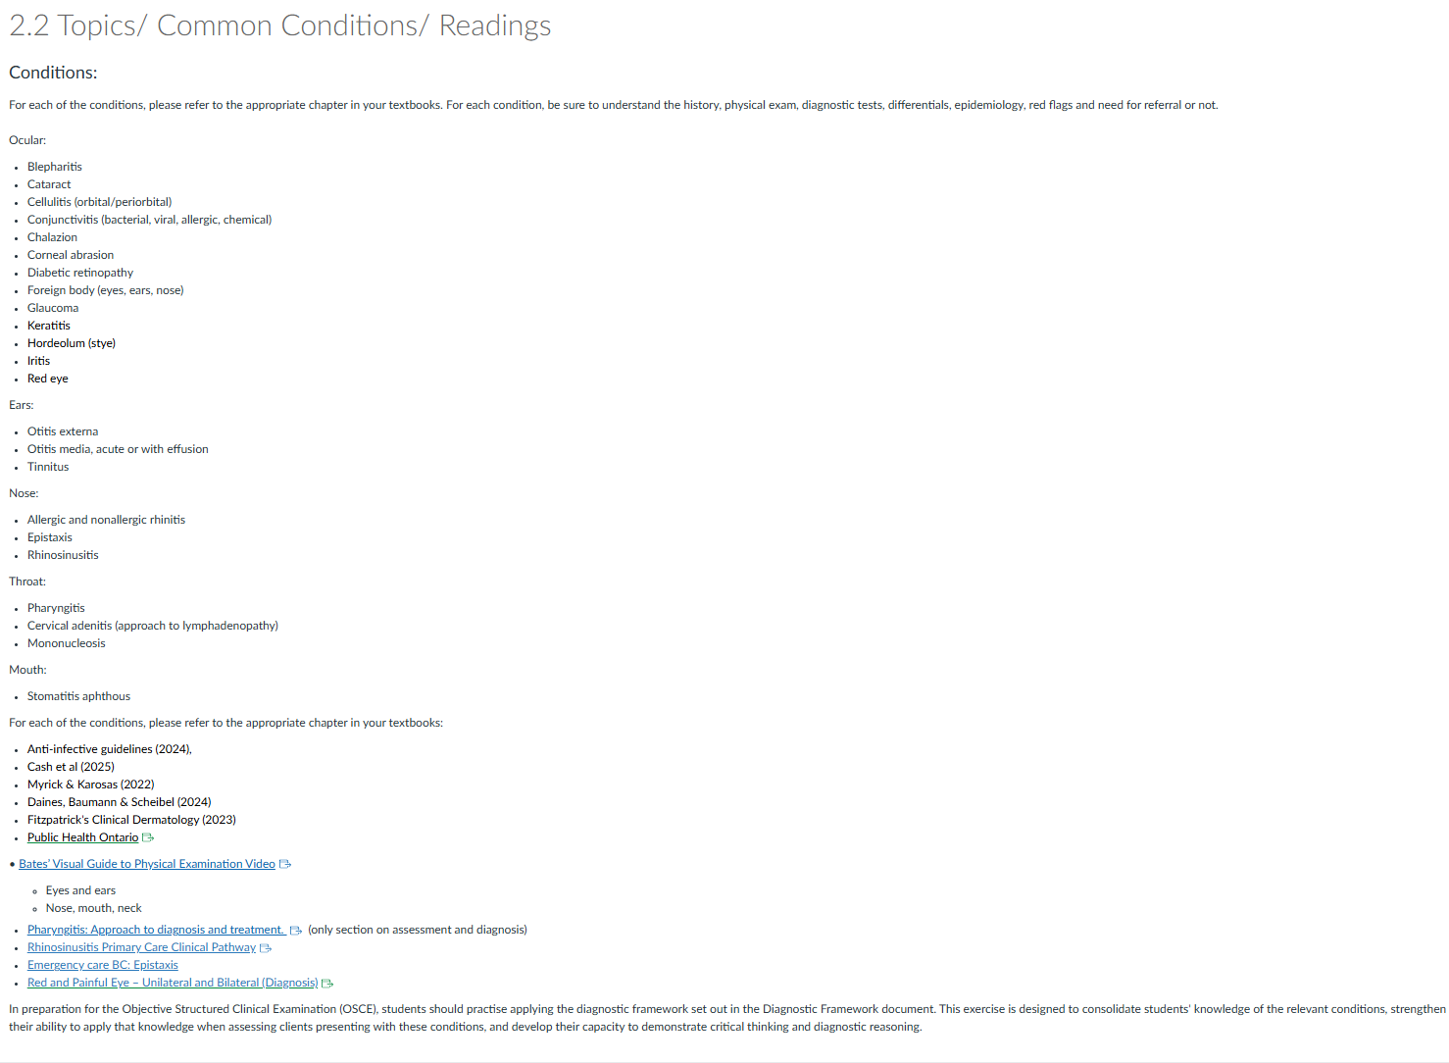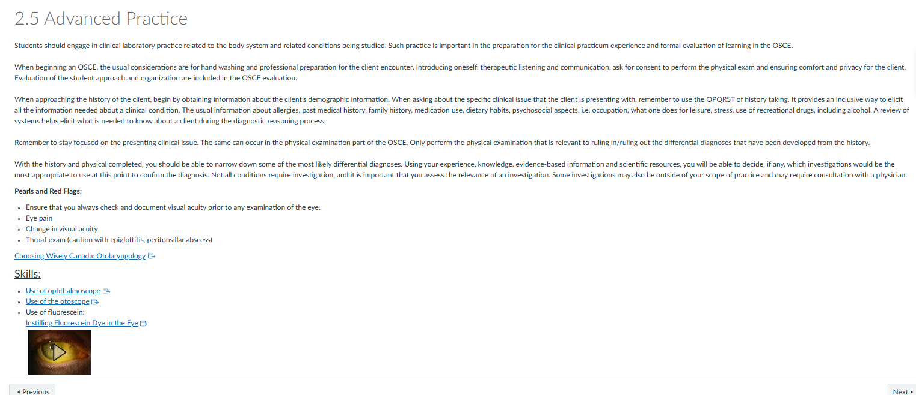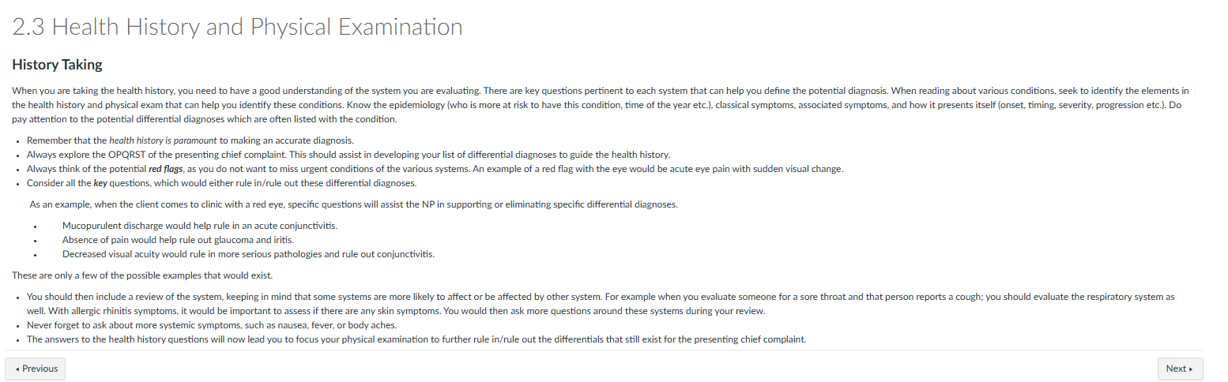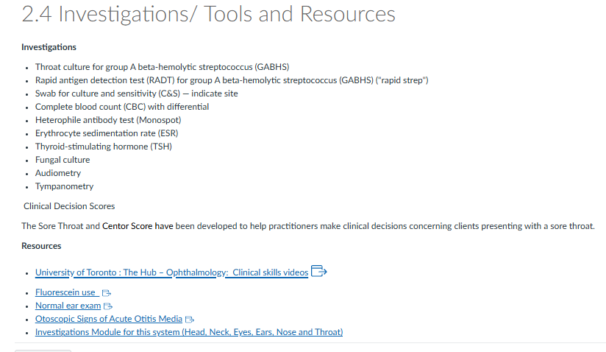2.6 Case Studies
Case Study #1

Terry (he/him), a 44-year-old construction worker, presents to your clinic reporting a red, itchy right eye for the past two days. He states that his right eyelid sticks together on waking and that he must wash the eye before he can open it. His left eye is bothering him as well now. He reports no change in vision, apart from increased sensitivity to bright light, and notes nasal congestion over the past five days.

Questions — Case #1

1. What additional key health history questions should the NP ask Terry?
2. What eye examination techniques will you include in your assessment?
3. Consider how your physical examination would differ if he had reported eye pain and a sensation of "something in my eye."
4. If the NP discovered a steel filing at the 3 o'clock position at the periphery of the iris, what would be the most appropriate next action?

Case Study #2

Beth (she/her), a 33-year-old early childhood educator, reports "excruciating pain in the left ear for the past 24 hours." She has no history of ear problems. The history reveals that she teaches swimming part-time for a competitive swim team at the local YMCA. She presents today because the pain is worsening, and she noticed white-to-yellowish drainage from her ear on her pillow this morning. She has no fever.

Questions — Case #2

1. At this stage, list the differential diagnoses the NP should consider based on Beth's presenting symptoms.
2. What physical findings would the NP expect to observe during the examination?
3. What is the most likely causative microorganism?
4. If the tympanic membrane could not be visualized, how should the NP rule out a middle ear infection?

Case Study #3

Eric (he/they), an 18-year-old college student, presents to the walk-in clinic with a fever, headache, and sore throat for the past three days. He informs the NP that he has difficulty swallowing, feels fatigued, and has developed a dry cough. He maintains his fluid intake but eats only soup due to difficulty swallowing. He denies any nausea, vomiting, or diarrhea. He presents today because he feels worse than he would with a simple cold.

Question 1: At this stage, list the differential diagnoses the NP should consider based on Eric's presenting symptoms. Provide your rationale.

The physical examination reveals:

• Temperature: 38.2 °C (tympanic).
• Lymphatic system: bilateral anterior cervical and submental lymphadenopathy, soft, mobile, and tender.
• HEENT:
• Nose: erythematous nasal turbinate, no discharge.
• Throat: inflamed pharynx.
• Tonsils: greyish-white exudate.
• The remainder of the examination is unremarkable.

Question 2: What is the total score using the Sore Throat Score?
Question 3: How predictive of a group A streptococcal (GAS) infection are this client's signs and symptoms?
Question 4: What complications are you concerned about, and what is the risk of these if treatment is delayed?
Question 5: Based on the clinical findings, what diagnostic investigations, if any, should the NP order? Provide your rationale.
Question 6: If the NP had noted splenomegaly during the physical examination, would this have changed the diagnostic reasoning?

OSCE Station: Acute Otitis Media (AOM)
You are seeing a pediatric patient in a primary care clinic, accompanied by a parent/caregiver. Take a focused history from the caregiver, review the simulated otoscopic examination findings, and communicate your working diagnosis and plan. You have 15 minutes before feedback.
Presenting complaint: “My child has been pulling at their ear and crying all night.”

Standardized Patient
Caregiver tells you: “She’s been tugging at her right ear since yesterday and had a fever last night. She barely slept.”

History: Reveal Only if Asked
- Age/sex: 2-year-old girl
- Onset: Ear tugging and fussiness started approximately 36 hours ago and worsened overnight
- Symptoms: Subjective fever/felt warm, irritability, decreased appetite, disrupted sleep, no ear discharge
- Preceding illness: Runny nose and mild cough beginning approximately 5 days ago. Upper respiratory infection preceding AOM is classic.
- Denies: Vomiting, rash, neck stiffness, lethargy, or tugging/pain in both ears. Symptoms are unilateral.
- Daycare: Attends daycare 3 days per week. A few other children have recently had colds.
- Past medical history: Born full term, no chronic conditions, no previous ear infections
- Medications: Caregiver gave weight-based acetaminophen last night with some relief
- Allergies: NKDA
- Immunizations: Up to date, including pneumococcal conjugate vaccine (PCV)
- Feeding: No bottle-propping or supine feeding reported
- Smoke exposure: None in the home

Red Flags: Answer “No” Unless Specifically Asked
- No stiff neck, bulging fontanelle if younger, persistent vomiting, lethargy/poor arousability, or facial droop
- No mastoid swelling, redness, or tenderness behind the ear
- No ear discharge, which would suggest tympanic membrane perforation

Vitals
- Temperature: 38.9°C, tympanic
- Heart rate: 118
- Respiratory rate: 26
- Weight: 13 kg
- General appearance: Fussy but consolable and interactive when distracted

Otoscopic Examination Findings
- Right tympanic membrane: Bulging, erythematous, and opaque, with loss of normal landmarks and reduced mobility on pneumatic otoscopy
- Left tympanic membrane: Normal, pearly grey, landmarks visible, and intact light reflex
- No perforation or discharge
- External canals normal bilaterally

Diagnostic Criteria Reference
Criterion | Finding in This Case
Acute onset of symptoms | Yes, approximately 36 hours
Middle-ear effusion | Yes, bulging and reduced tympanic membrane mobility
Signs/symptoms of middle-ear inflammation | Yes, erythema of tympanic membrane plus irritability/fever
Laterality | Unilateral, right
Severity | Moderate to severe. Marked bulging and fever ≥39°C would push to severe.
This presentation meets the diagnostic criteria for AOM. The candidate should discuss watchful waiting versus immediate antibiotics based on age, severity, and laterality. Exact prescribing decisions can be deferred if not yet covered in the curriculum. Focus on the reasoning framework.

Assessment Checklist

History
☐ Introduces self, confirms patient/caregiver identity, and explains purpose
☐ Elicits onset, duration, and laterality of ear symptoms
☐ Asks about associated symptoms: fever, irritability, sleep/appetite changes, and discharge
☐ Asks about preceding URI symptoms
☐ Screens for red flags: lethargy, stiff neck, mastoid swelling, and persistent vomiting
☐ Asks about risk factors: daycare, smoke exposure, feeding position, and previous ear infections
☐ Reviews immunization status, including PCV
☐ Uses caregiver-appropriate, empathetic communication because the patient is a child

Physical Examination
☐ States intent to check vital signs and weight
☐ Requests and interprets otoscopic findings for both ears
☐ Asks about or notes pneumatic otoscopy and tympanic membrane mobility
☐ Checks for mastoid tenderness or swelling
☐ Assesses general appearance and hydration status

Clinical Reasoning
☐ Applies diagnostic criteria correctly: acute onset, effusion, and inflammation
☐ Distinguishes AOM from otitis media with effusion and otitis externa
☐ Discusses watchful waiting versus antibiotic therapy with appropriate rationale based on age, severity, and laterality
☐ Identifies the need for follow-up and safety-netting

Communication
☐ Explains findings and the plan using caregiver-friendly language
☐ Addresses the caregiver’s concerns and answers questions
☐ Discusses pain management, such as weight-based analgesia
☐ Provides clear safety-netting regarding when to return: worsening fever, ear discharge, lethargy, or facial swelling
☐ Demonstrates empathy and professionalism throughout

Debrief Prompts
- What features distinguish AOM from otitis media with effusion?
- How would your management change if this were a 6-month-old instead of a 2-year-old?
- What would make you consider watchful waiting rather than immediate antibiotics?
- What anatomical factors make young children more prone to AOM?

Facilitator Notes
- Swap roles and repeat with an otitis media with effusion variant: no fever, no acute pain, tympanic membrane retracted or neutral with effusion but no bulging or erythema, and the caregiver reports only mild hearing concerns. This is useful for teaching the distinction between AOM and OME.
- For a more advanced group, add a mastoiditis “spot the emergency” variant: post-auricular swelling, erythema, tenderness, and protruding auricle.
HEENT / Throat Assessments & Investigations
What it is • When to use it • How to interpret it • What to look for
1. Investigations
Investigation | What it is | When I would use it | How to read it / what to look for
Throat culture for GABHS | Throat swab cultured specifically for Group A beta-hemolytic Streptococcus (GAS/GABHS). | Suspected streptococcal pharyngitis; especially when confirmation is required or RADT is negative but clinical suspicion remains. | Positive = GAS isolated and supports strep pharyngitis. Negative = GAS not isolated. More sensitive than RADT, but slower.
Rapid antigen detection test (RADT) / rapid strep | Rapid throat swab that detects GAS antigen. | Acute sore throat when GAS is clinically suspected. | Positive = strong evidence of GAS. Negative = GAS not detected, but false negatives occur because sensitivity is lower than culture. Depending on age/guideline, a negative test may require culture confirmation.
Swab for culture & sensitivity (C&S) | Grows organisms from a specific body site and tests antimicrobial susceptibility. | Suspected bacterial infection, especially recurrent, unusual, severe, treatment-resistant infection, drainage/wound, or ear discharge. Always indicate the site. | Review: 1) organism identified and 2) susceptibility. S = susceptible; R = resistant; I = intermediate/increased exposure depending on lab. Interpret organism in context of the sampled site.
CBC with differential | Measures RBCs, WBCs, platelets, and the distribution of WBC types. | Systemic illness, prolonged/severe infection, suspected mononucleosis, bacterial infection, or hematologic abnormality. | For infection, focus on WBC count + differential. Neutrophilia often suggests bacterial/inflammatory process. Lymphocytosis often suggests viral illness. Atypical lymphocytes may occur with EBV. Also note anemia, thrombocytopenia, or other unexpected abnormalities.
Heterophile antibody test (Monospot) | Detects heterophile antibodies associated with EBV infectious mononucleosis. | Suspected mono: fever, marked fatigue, exudative pharyngitis, posterior cervical lymphadenopathy +/- splenomegaly. | Positive supports infectious mononucleosis. A negative result does not fully exclude early EBV, especially early in illness or in young children. If suspicion remains high, consider EBV-specific serology.
Erythrocyte sedimentation rate (ESR) | Nonspecific marker of inflammation based on how quickly red blood cells settle. | When a broader inflammatory/systemic process is suspected rather than routine uncomplicated pharyngitis. | Elevated ESR = inflammation is present but does not identify the cause or location. Interpret with history, exam, and other tests. Can rise with infection, inflammatory/autoimmune disease, malignancy, and other conditions.
Thyroid-stimulating hormone (TSH) | Measures TSH and indirectly assesses thyroid function. | Neck symptoms/goiter, fatigue, weight change, heat/cold intolerance, palpitations, menstrual changes, or suspected thyroid dysfunction. | High TSH commonly suggests primary hypothyroidism. Low TSH commonly suggests hyperthyroidism. Usually interpret with free T4 and the clinical picture.
Fungal culture | Culture used to identify fungal organisms. | Persistent/recurrent suspected fungal infection, atypical presentation, treatment failure, immunocompromised patient, or when organism identification is needed. | Positive = fungal organism identified. Decide whether it matches the clinical picture versus colonization/contamination. May guide antifungal therapy.
Audiometry | Measures hearing thresholds across different frequencies. | Reported hearing loss, failed hearing screen, chronic/recurrent ear disease, tinnitus, or concern for conductive/sensorineural hearing loss. | Review hearing threshold in dB across frequencies. Determine degree, symmetry, and pattern of hearing loss. Air vs bone conduction helps distinguish conductive from sensorineural loss.
Tympanometry | Measures tympanic membrane compliance/movement and middle-ear pressure. | Suspected middle-ear effusion, eustachian tube dysfunction, recurrent otitis media, or hearing concerns. | Type A = normal middle-ear function. Type B = flat tracing, commonly middle-ear effusion; perforation may also cause this depending on ear canal volume. Type C = negative middle-ear pressure, suggesting eustachian tube dysfunction.
2. Quick Approach to a Patient With a Sore Throat
Does it look viral?
Cough
Rhinorrhea
Hoarseness
Oral ulcers
Conjunctivitis
Interpretation: These findings make GAS less likely.
Does it look like GAS?
Fever
Tonsillar swelling or exudate
Tender anterior cervical lymph nodes
Absence of cough
Age/risk factors consistent with GAS
Does it look like EBV / mononucleosis?
Marked fatigue
Exudative pharyngitis
Posterior cervical lymphadenopathy
Generalized lymphadenopathy
Possible splenomegaly
Consider: CBC with differential + Monospot/EBV testing when clinically appropriate.
3. Centor / Modified Centor (McIsaac) Score
Used to estimate the likelihood of GAS pharyngitis and help determine whether GAS testing is appropriate.
Finding | Points
Tonsillar exudate or swelling | +1
Tender anterior cervical lymphadenopathy | +1
Fever >38°C | +1
Absence of cough | +1
Age 3–14 years | +1
Age 15–44 years | 0
Age ≥45 years | −1
How to use it: A lower score means GAS is less likely; as the score increases, the probability of GAS increases and testing becomes more appropriate.
Key point: Centor does not diagnose strep on its own. It estimates pretest probability and supports testing decisions.
4. Sore Throat Score
The Sore Throat Score uses the same major clinical predictors for GAS:
Temperature >38°C
Absence of cough
Swollen/tender anterior cervical nodes
Tonsillar swelling or exudate
Age adjustment
Purpose: Clinical findings → estimate probability of GAS → determine whether testing or treatment consideration is appropriate according to the guideline being used.
HIGH-YIELD NODE DISTINCTION
GAS pharyngitis: tender ANTERIOR cervical lymph nodes
EBV / mononucleosis: classically POSTERIOR cervical lymph nodes
5. Quick Reference: Presentation → Investigation
Clinical presentation | Think about
Possible GAS pharyngitis | Centor/Sore Throat Score → RADT +/- throat culture
Exudative throat + marked fatigue + posterior nodes | CBC + differential + Monospot
Unusual/recurrent bacterial infection | Site-specific C&S
Persistent/systemic inflammation | CBC +/- ESR
Thyroid symptoms or goiter | TSH +/- free T4
Possible fungal infection or treatment failure | Fungal culture
Hearing loss | Audiometry
Middle-ear effusion / eustachian tube dysfunction | Tympanometry

